DIE# 15191/15192 – H-PAC (Skid)

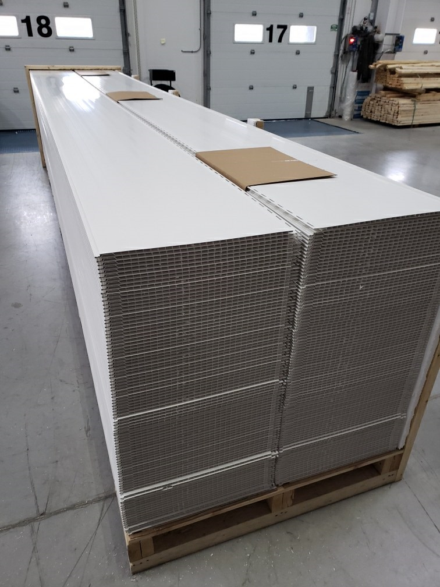
Top Piece to be flipped upside down to avoid damage to exposed surface

Cardboard down the middle to prevent panel sliding into other side

